**West Middle PTO General Meeting**

**March 14, 2023 7pm Library**

**Attendees:** Dr. Kealen, Myriam Gitt, Stephanie Stokes, Carrie Bowers, Casey Pfarr, Tamara Welliver, Jeanna Gossett, Marcy Curtis, Lori Conran, Julie Wyatt and Dana Lorenz

**Presidents’ Report**: Julie Wyatt and Myriam Andrews

Review and approve February Meeting Minute

Motion to Approve: Myriam Andrews Second: Stephanie Stokes

* Special Projects: Bike rack on order. It will hold 7 bikes. Basketball pole pads and replacement gaga balls delivered. Discussion at April budget meeting on replacement balls for recess; basketball, gaga balls, kickballs: Teacher Grant or add a line item for replacements? A recommendation was to consider Specials supplies as line item.
* 2023/2024 PTO Board Positions

Nomination Committee and Process. 7 forms have been filled out. Missing Committee is Community. Accepting nominations through March 31, 2023. Nominations presented at April meeting. Voting at May meeting.

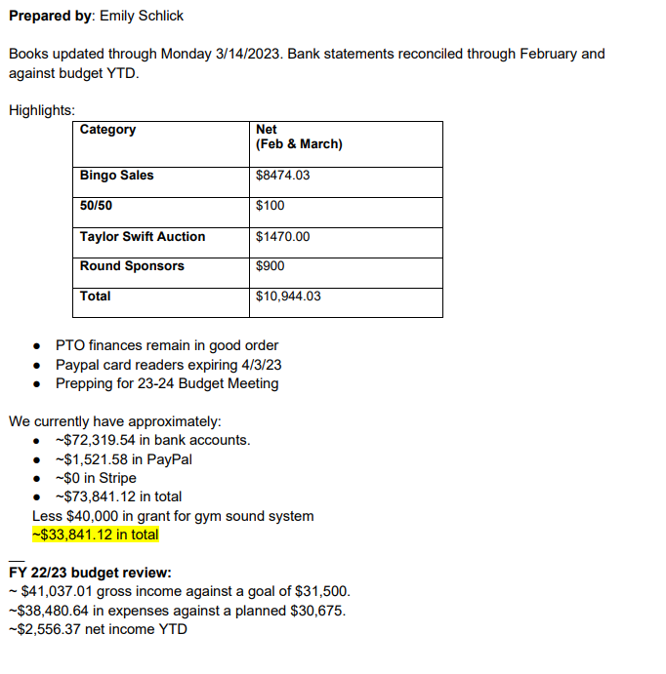

**Fundraising Report: Pamela Betz and Jeanna Gossett (Shadows: Stephanie Stokes and Myriam Andrews)**

* Rock and Roll Bingo: Tables are sold out, but Taylor Swift Raffle tickets are available for purchase until 4/1/23 at 12 noon. Two round sponsorships available for purchase. The week after Spring Break, we will begin to market Wesley, the 8-week puppy. Discussed having a slide or video for the sound system renovation to share with the families for on-the-spot donations. Thank you to our sponsors for participating!
* Spirit Wear: No update.
* Direct Giving:  $8023.58 YTD. $12,000 goal.
* Pretzel Sales: One day left this year, April 14th at all lunches.
* Kendra Scott Fundraiser $245 earned.
* **Communications Report**:  Jen McCurdy- keep up with PTO through monthly emails, Facebook posts and updates in Dr. Kealen’s Longhorn Way

**Community Report**:  Anne Branch

* Lucky to be a Longhorn Fun Run:  Thank you to Robyn Hayes and committee for the inaugural Fun Run for West Middle.  It was a chilly morning, but the route was great and having the Coffee/Hot chocolate truck and free bagels were such a treat.
* Cotillion:  Jamie Gumpel. No report.
* Staff Appreciation:  Kate Deckelbaum. No report.
* 8th Grade Celebration:  Robyn Hayes, Mandy Kelly, Kristen Merriman. No report.
* Longhorn Pride/ Beautification:  Dr. Kealen. Tulips are blooming! Waiting for the weather to warm up to beautify the school!
* 6th Grade Rep:  Stephanie Stokes, Myriam Andrews. No report.
* 7th Grade Rep:  Aurella Clinkscale, Angie Stevens. No report.
* 8th Grade Rep:  Kate Deckelbaum, Lori Conran. No report.

**Principal’s Report**:  Dr. Kealen

* 850 tickets were sold for four showings of Matilda Jr.
* 6 babies have been born within the staff at West.
* Staffing at West Middle, 24-25’: Enrollment is decreasing next school year. Projection: 911-920, total enrollment, 266 6th grade students enrolled. Board policy target class size is 23, maximum is 26. Specials can have larger classroom sizes, P.E., Music, Business. One 6th grade team is going to dissolve. All full-time teachers are receiving contracts next year either at West or at other Parkway schools.

Old Business: Inquired about the STAR room – progress. Dr. Kealen is checking in with the teacher.

New Business: None.

Next Meeting:  April 11, 2023 7pm Library